<https://barcode.tec-it.com/en/>

Kevin Arellano

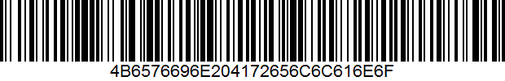

____________________________________________________________________________

David Carson

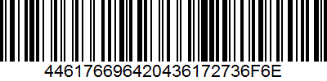

____________________________________________________________________________

Frank Garrahan

